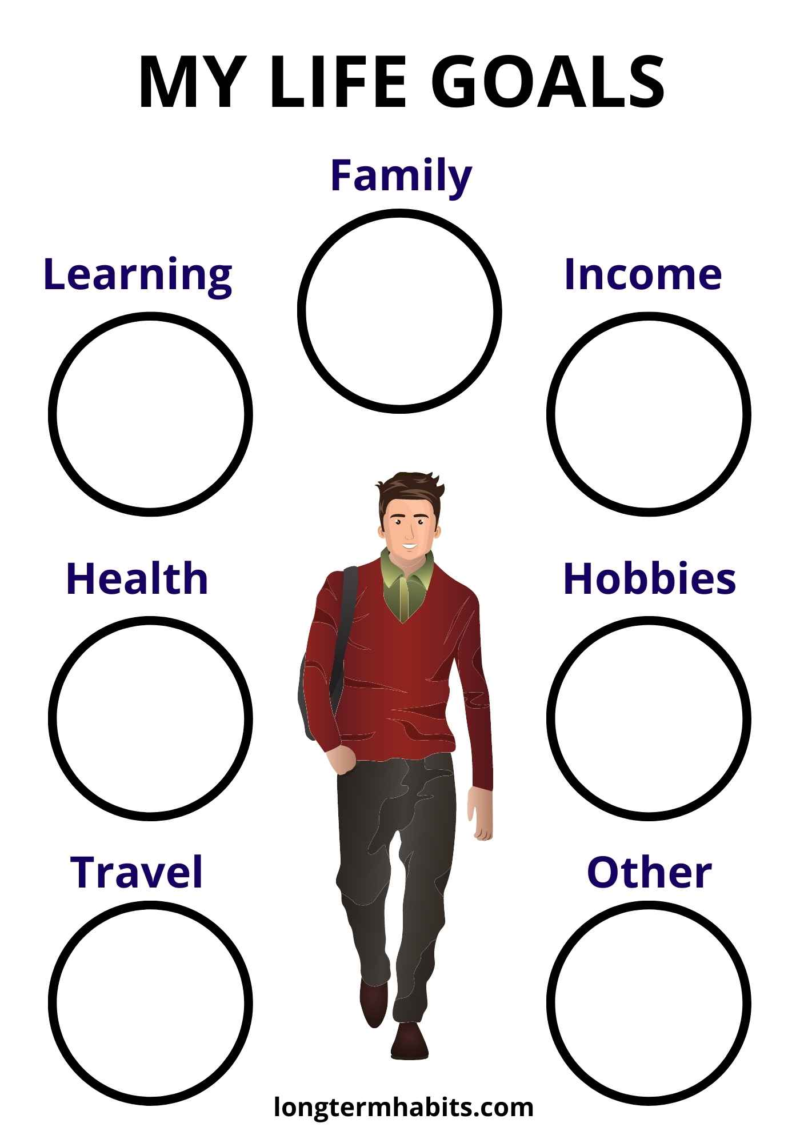

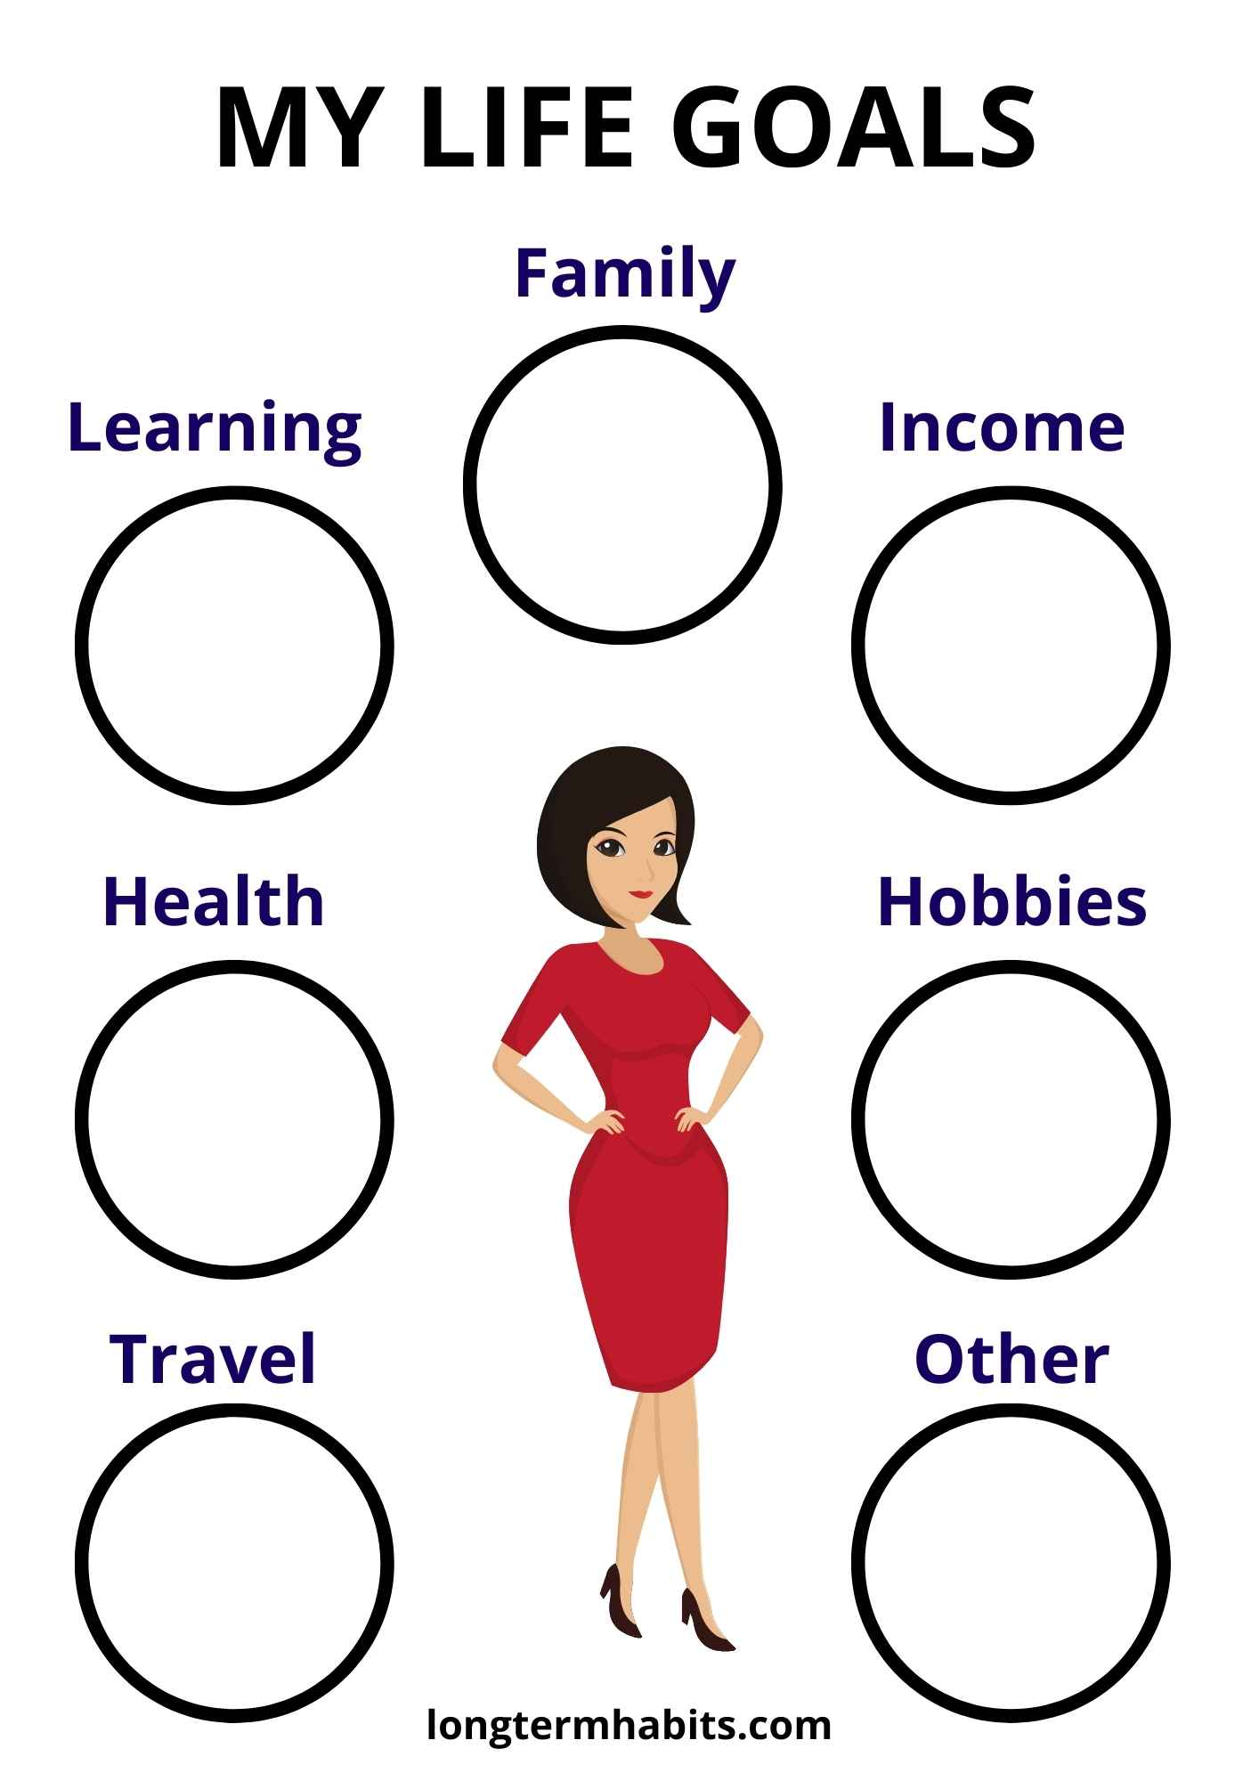

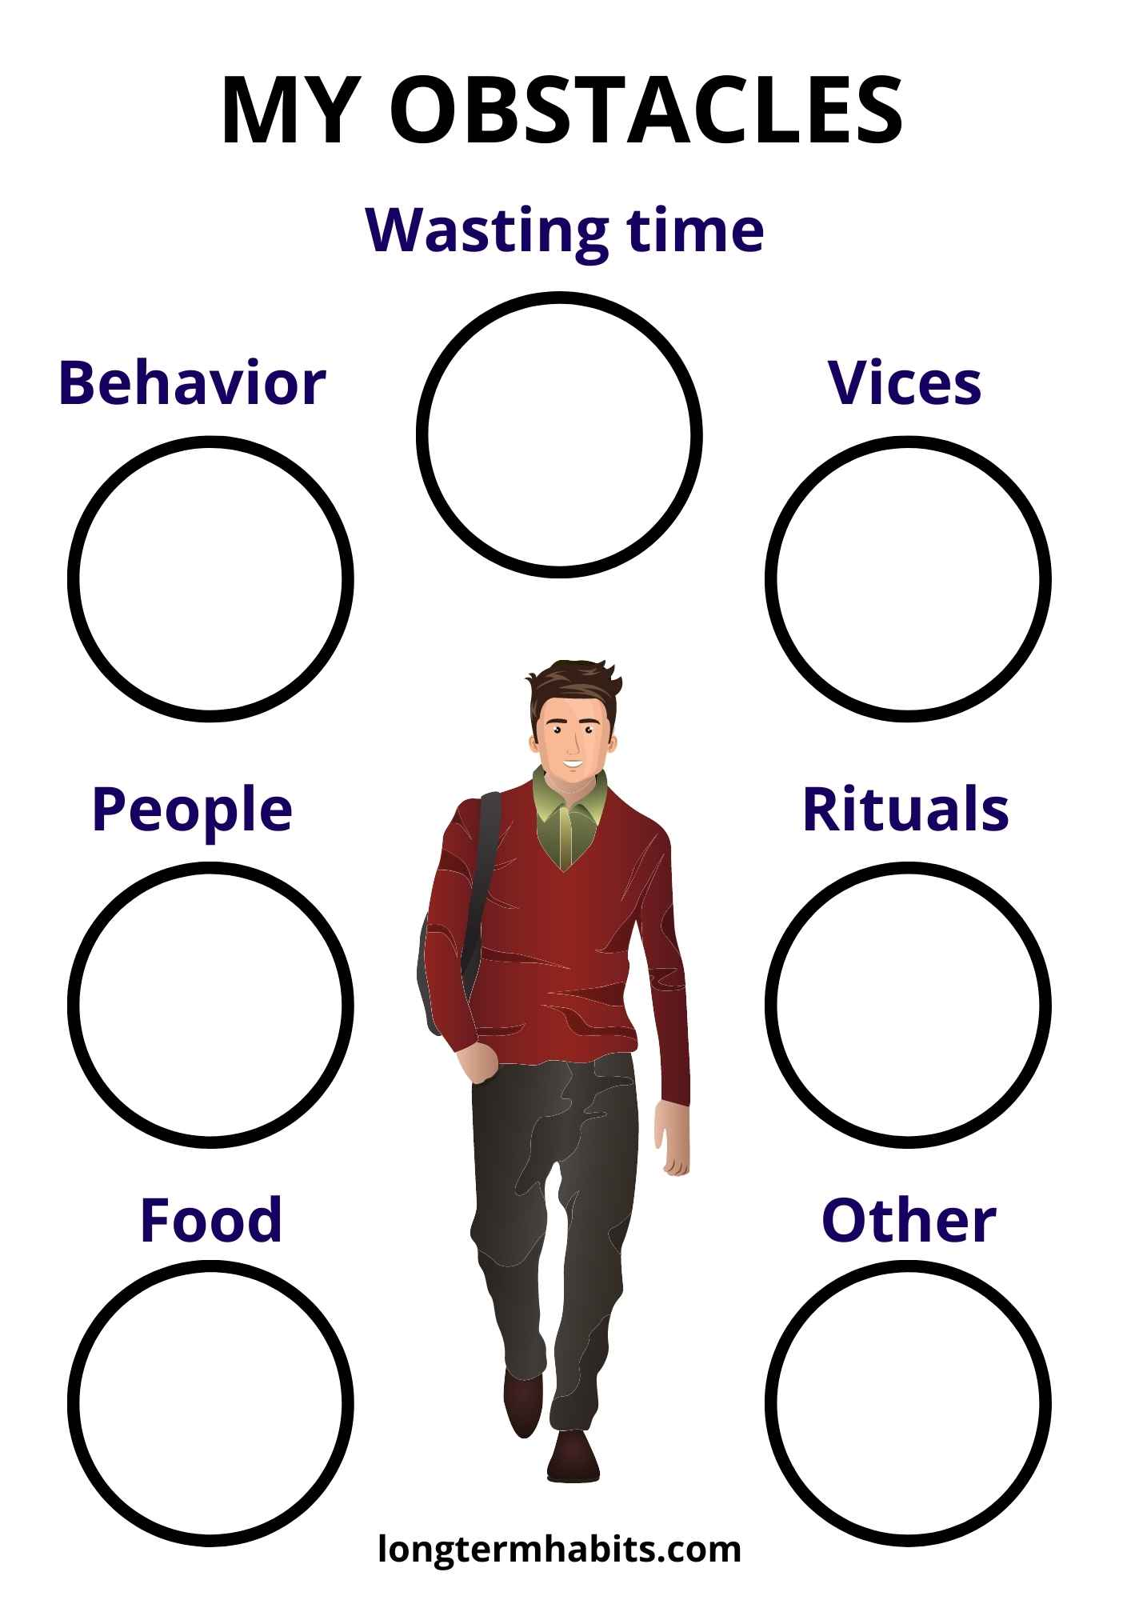

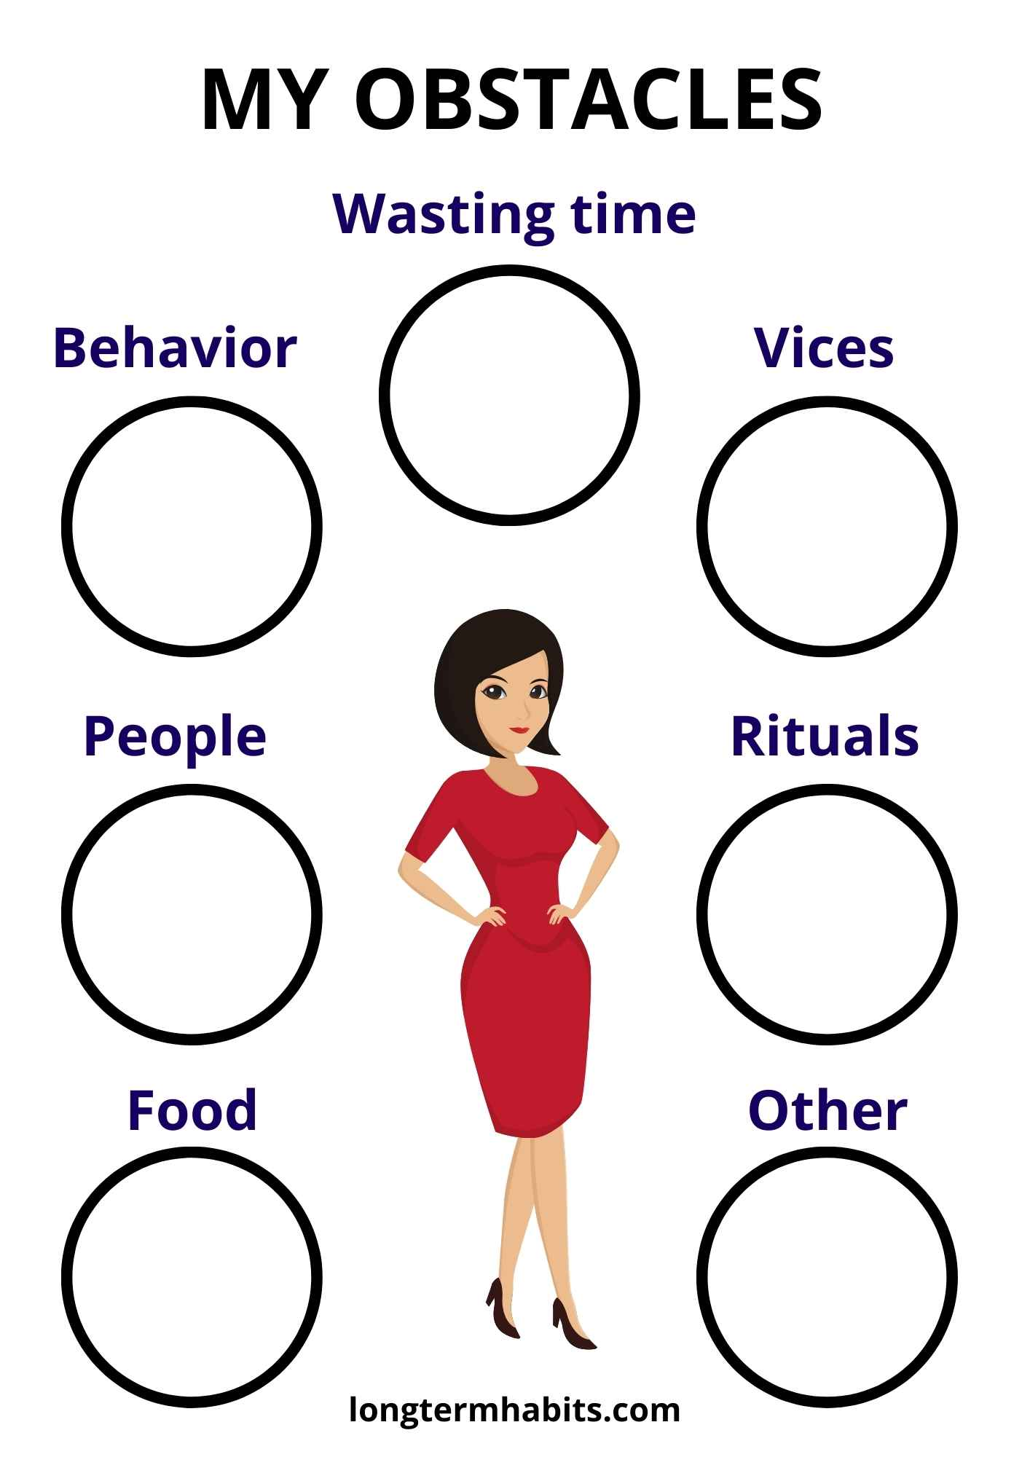

**Links:**

-The free audiobook - [*Fulfilling Life: A Matter of Personal Choice*](https://wp.me/abfXtr-Yr)

- [Great Books for a Great Life](https://longtermhabits.com/great-books-for-a-great-life/) - all the answers to your questions in one

**[](https://www.facebook.com/dugorocnenavike)**place

**-** [Long-Term habits group](https://www.facebook.com/groups/432295250735349)



[Long-Term Habits](https://longtermhabits.com/)